grep ‘linux’ ‘Desktop/demo/data’- This command is used to find the word linux in the text file.

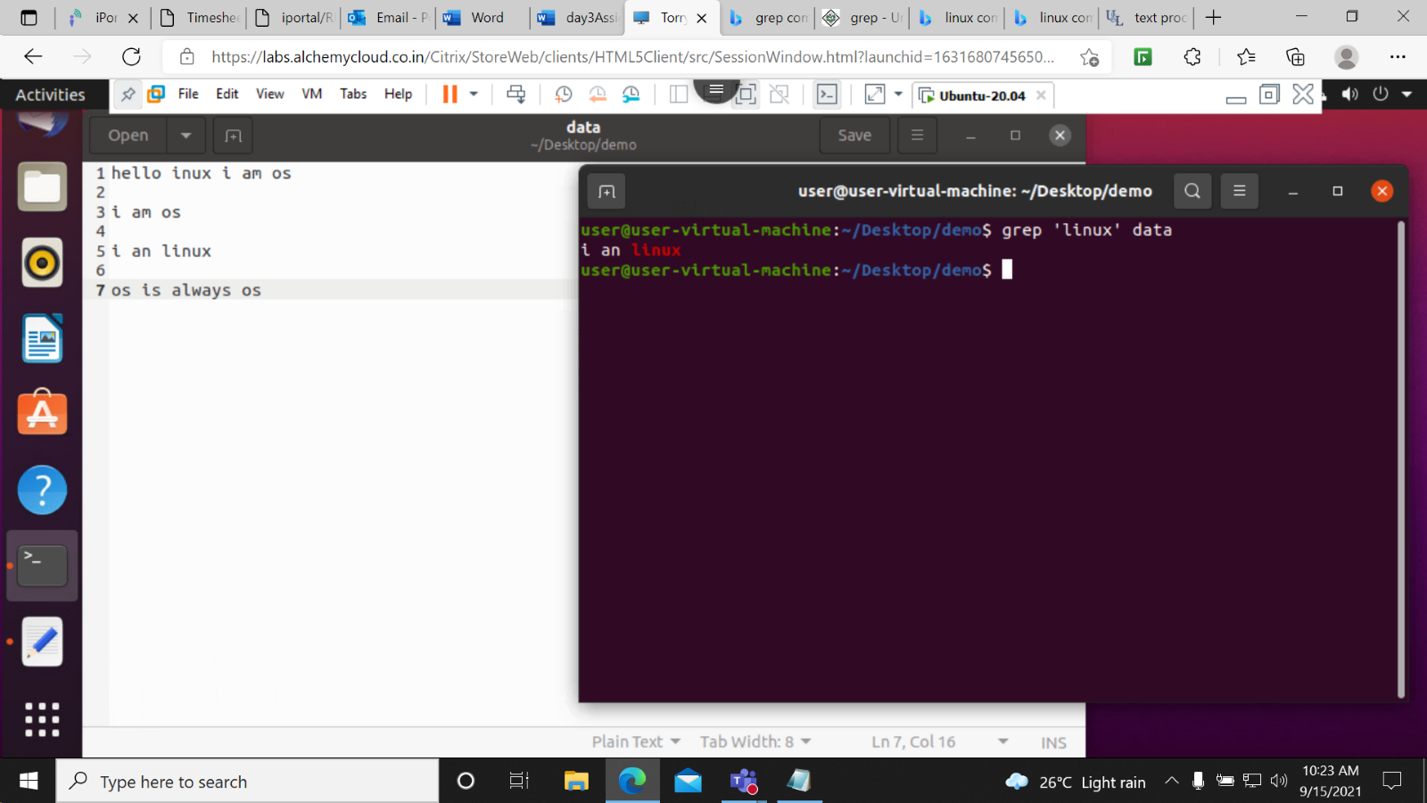

grep –i ‘linux’ data-

This command is used to ignore the cases in the file with name linux.

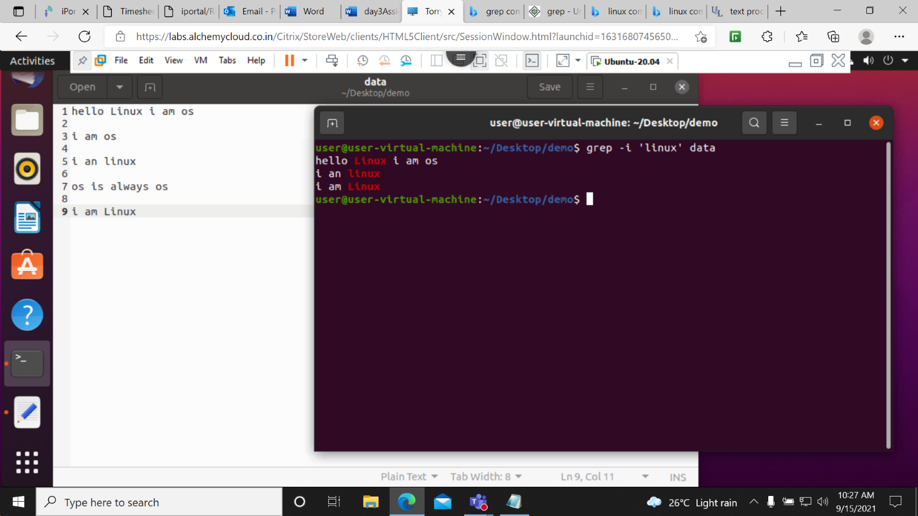

grep –c ‘linux’ data- This command is used to show the repeatability of the word in the lines the file.

It displays the number in which world linux is present.

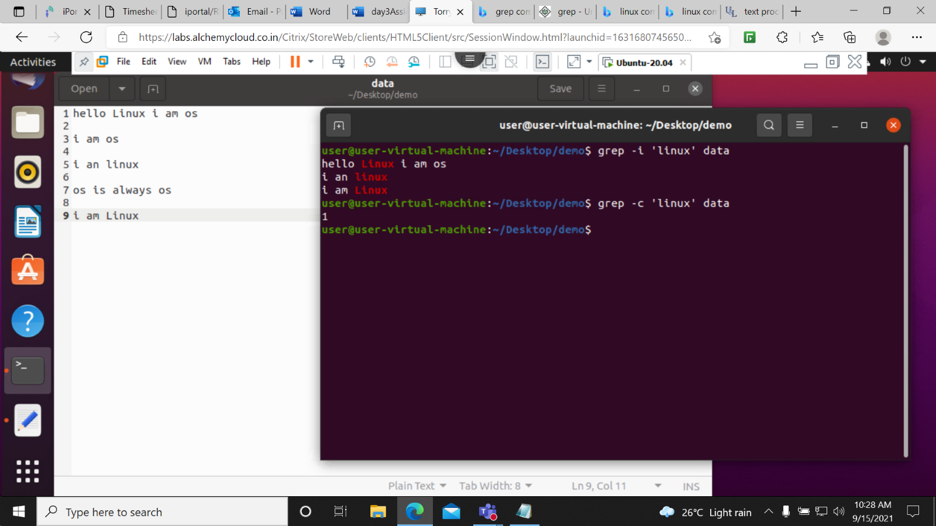

grep –L ‘linux’ \* - This command is used to show the file name which contain the world linux.

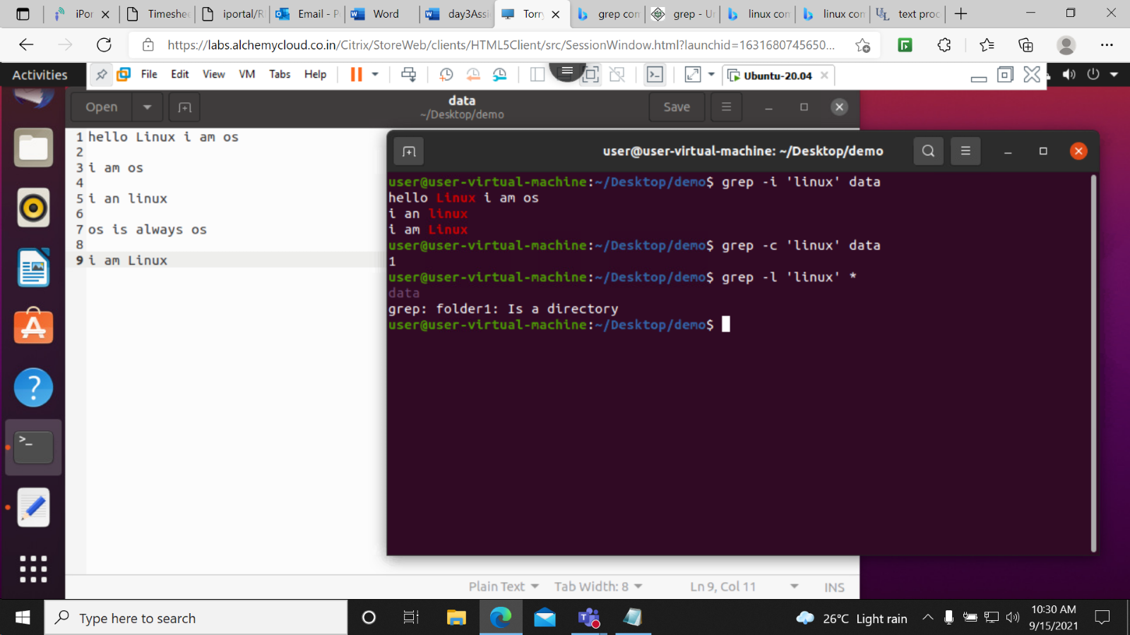

grep –w ‘linux’ data data1- This command is used to print the string in the file that contain the world.

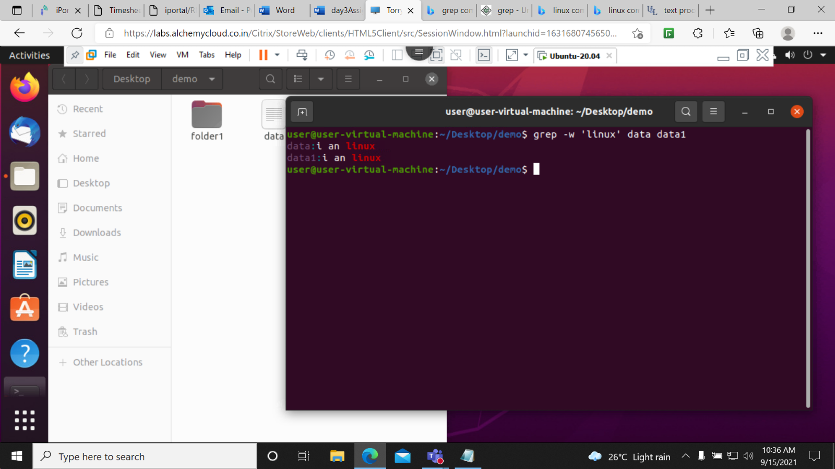

grep –o ‘linux’ data- This command is used to print the string that present in the file .it only present the string if the string was present in the the file.

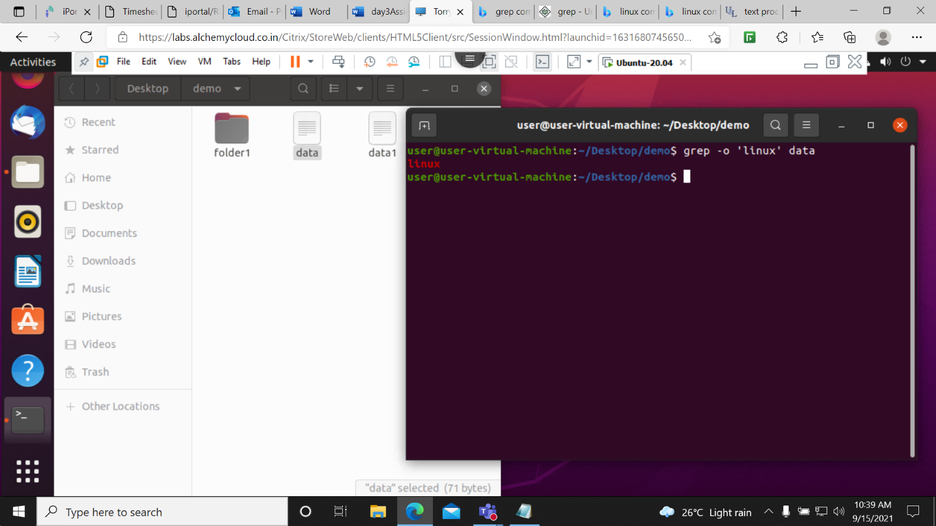

grep –w –o ‘linux’ data data1 – This command is used to fetch the string as well as the the file name .

This is the integration of two commands



grep –n ‘linux’ data data1- This command is used to print the number of the line in the files.

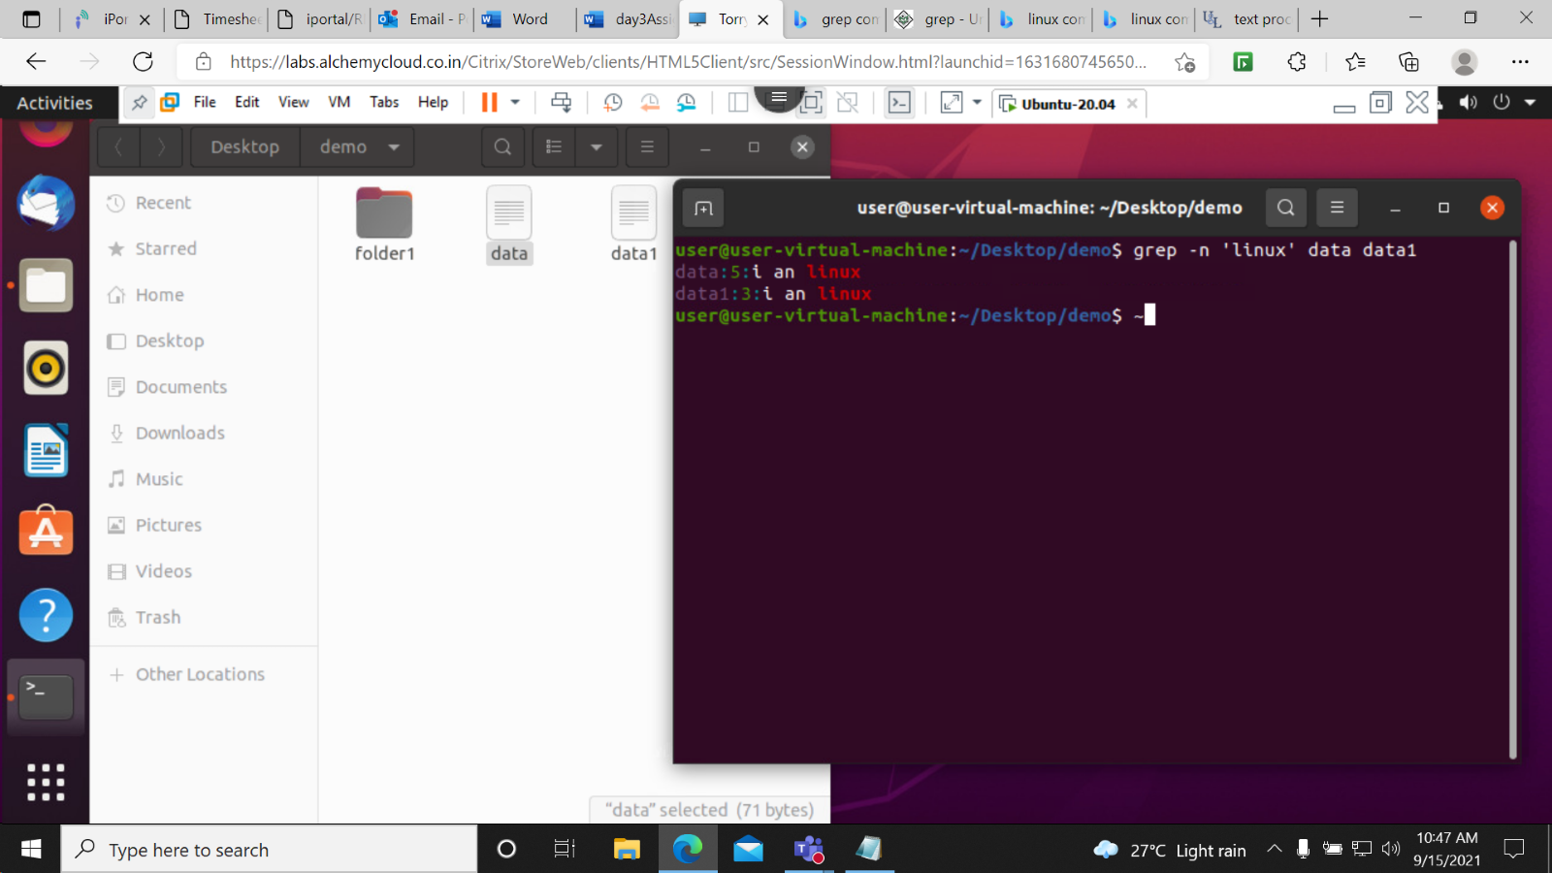

grep –v ‘linux’ data- This command is used to print the lines that do not contain the word linux.

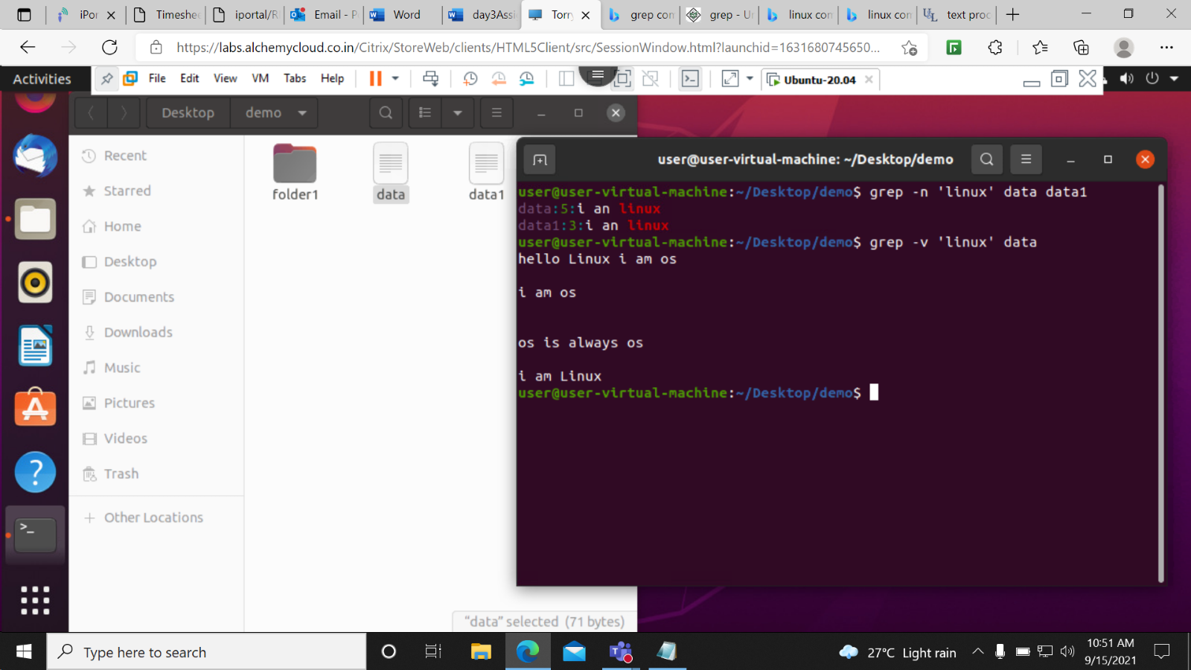

grep ‘^os’ data- This command is used to print the line that contain os at the starting of the line.

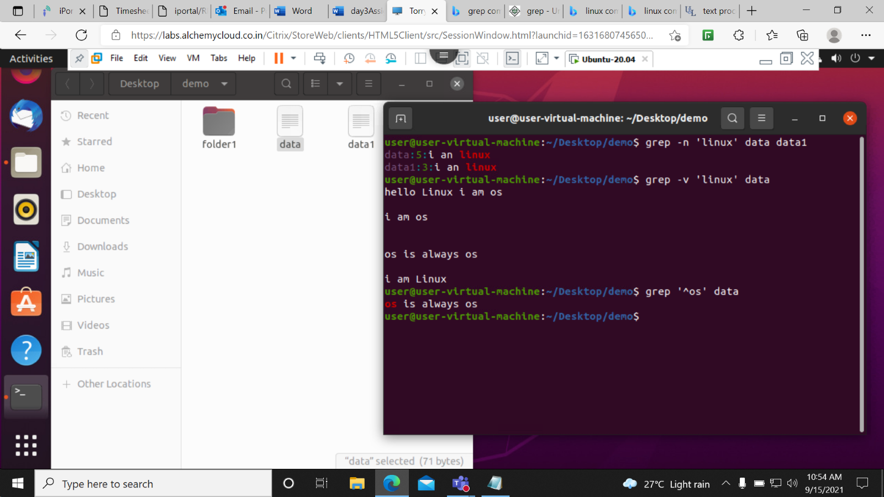

grep –won ‘inux’ data – This command is used to do three tasks at a time as it prints string, prints the line number and full fetch name

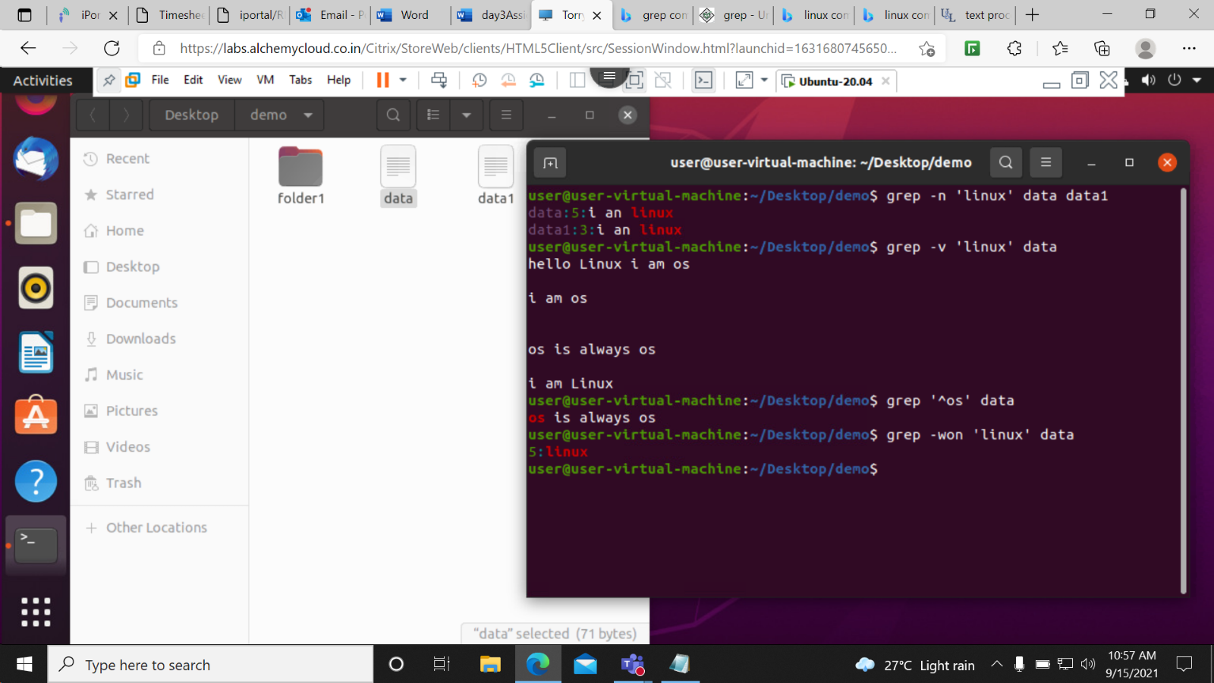

grep ‘os$’ dara – This command is used to print the the string that contain os at the end of line in the file.

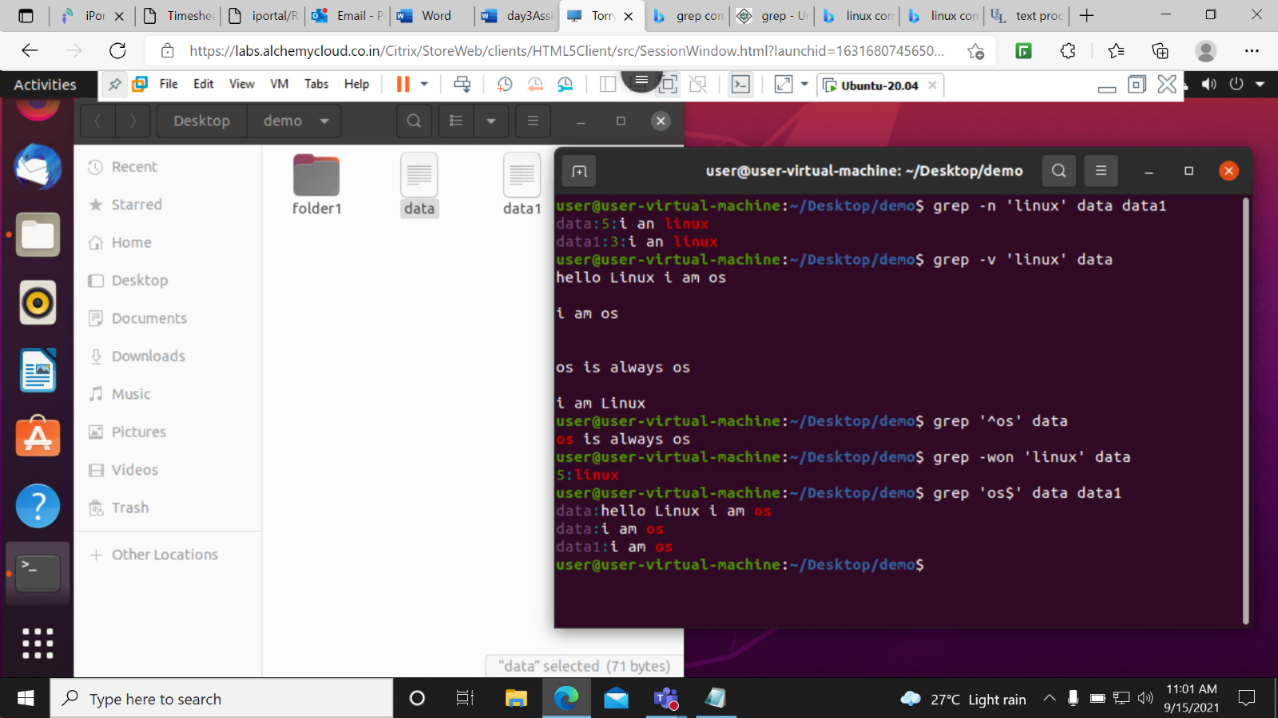

grep –E ‘i|os’ data data1- This command is used to print the lines that contain I at the starting of the string and os at the end of the string.

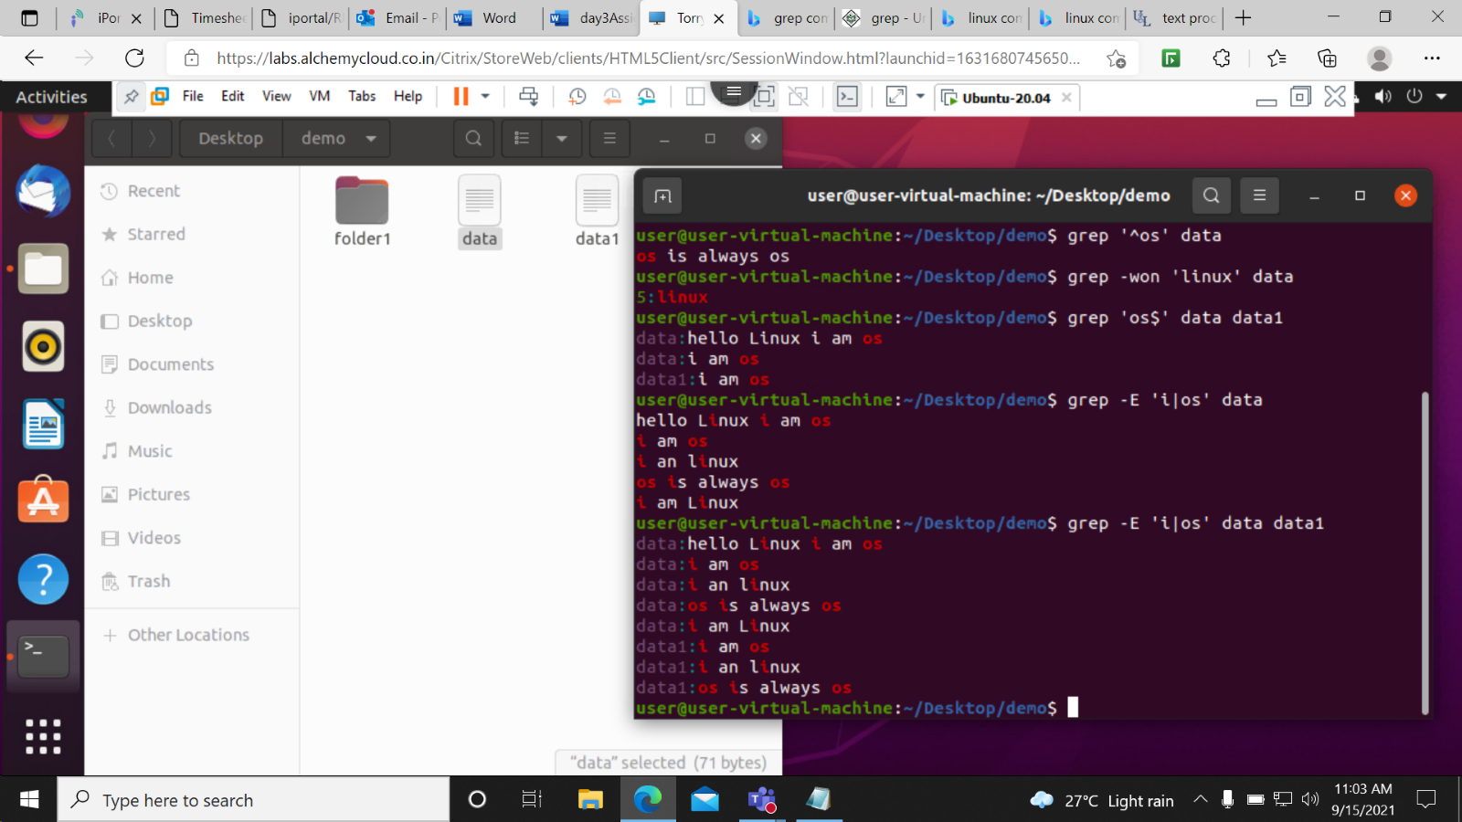

grep –ni -E ‘^h.p$’ data- It prints the word or string that starts with h and end with p in between there is one char.

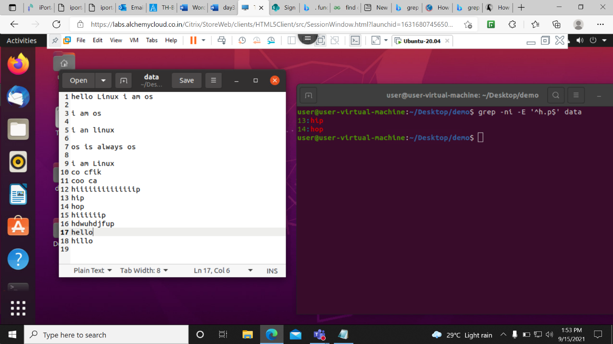

grep –ni –E ‘^h[i]p$’ data- This command is used to print only one char that present in the square bracket starting with h and ending with the p.

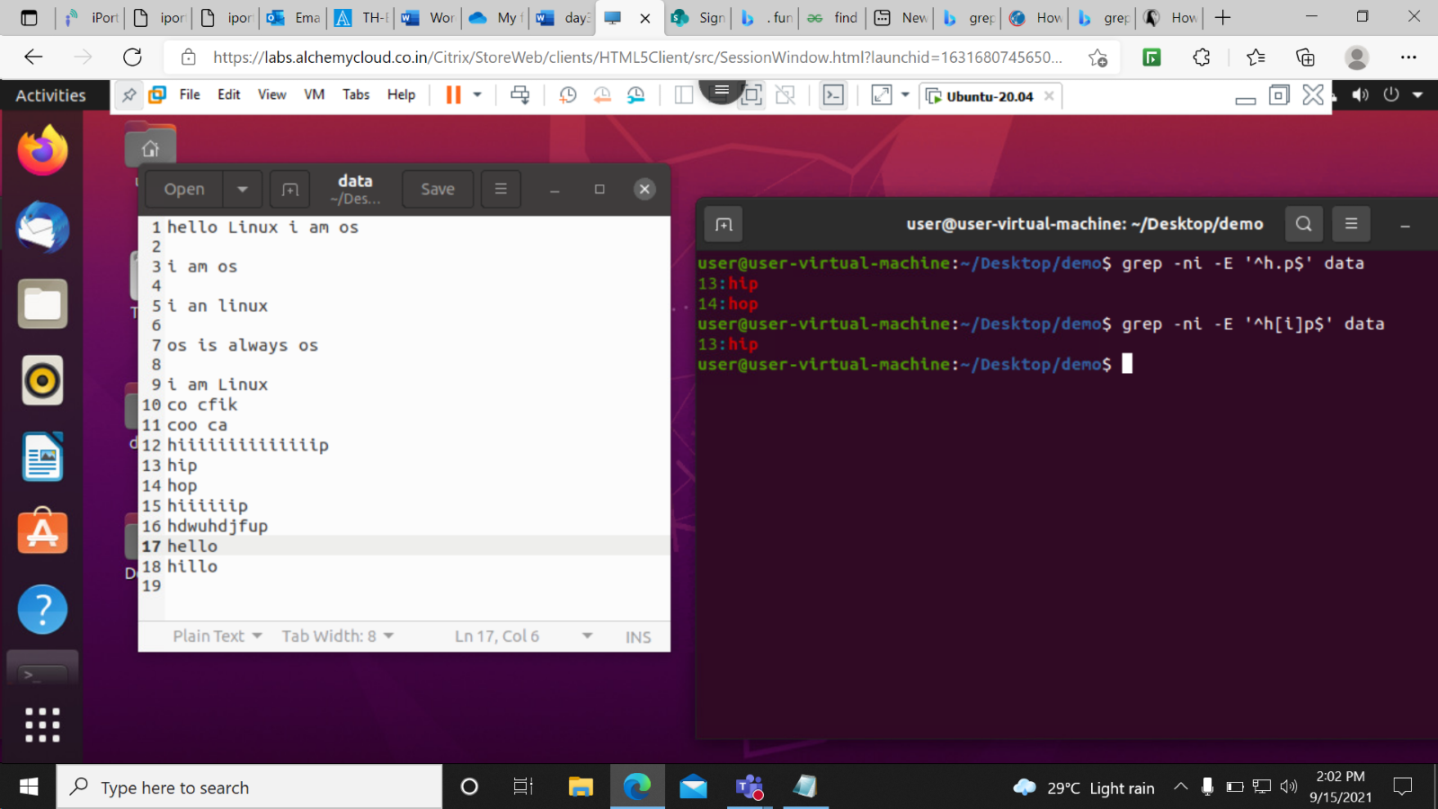

grep –ni –E ‘h.[i]\*p$ data- This command print the string when there is more than one i present in between starting point h and ending point p.

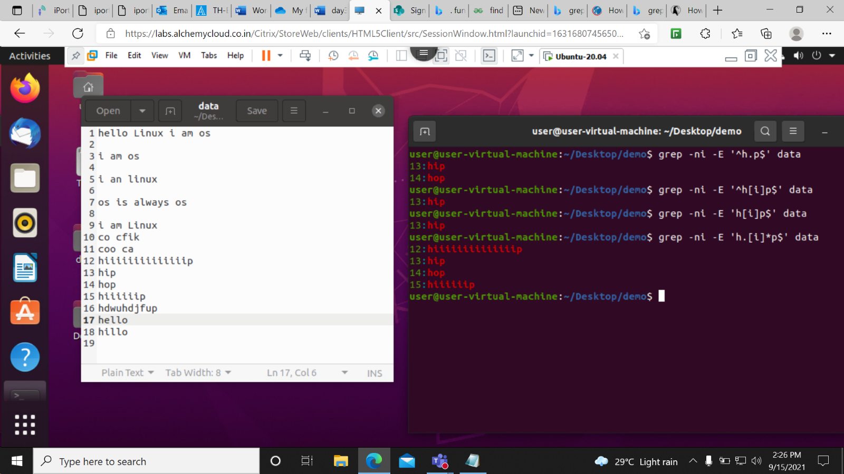

grep –ni –E “^h+p$” data- This command print the string when there is more than one i present in between starting point h and ending point p.

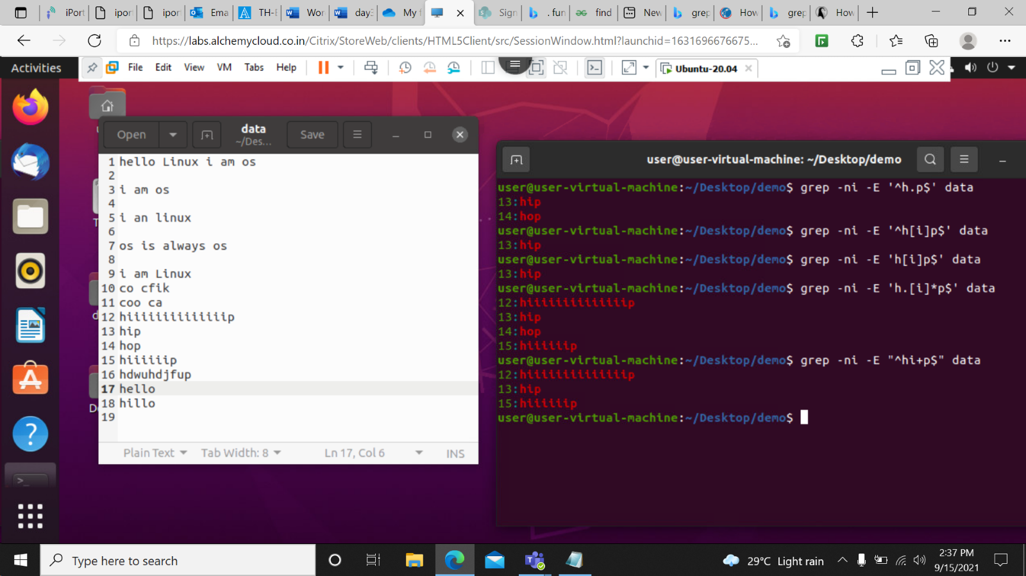

grep –n –E “[a-z].\*” data- This command is used to print all the char in-between a t-z in the file.

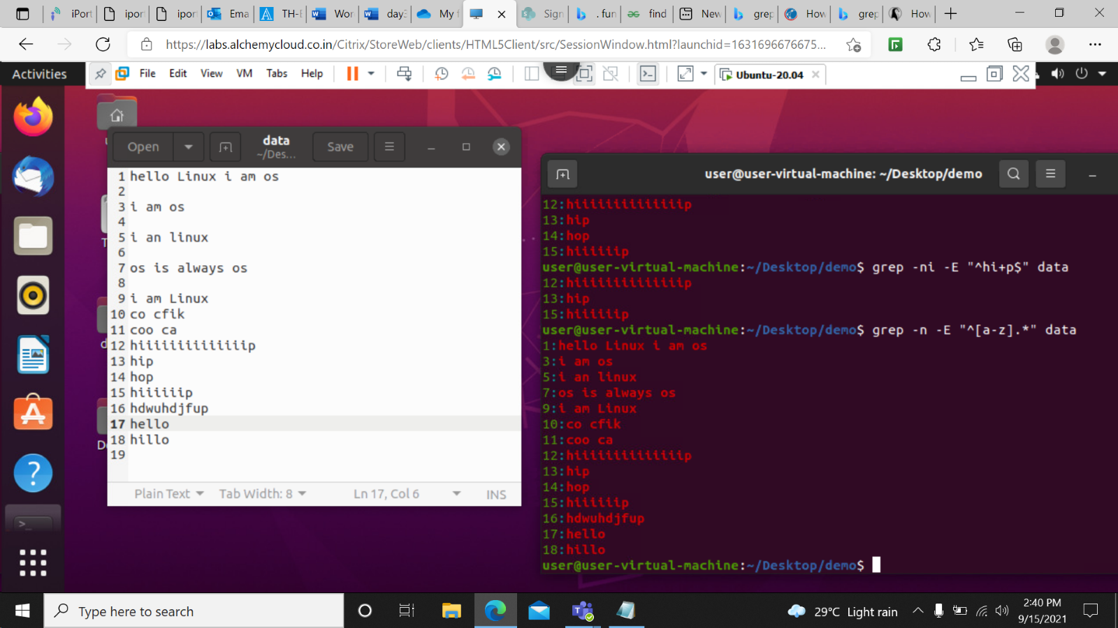

grep –n –E “\[\]$” data- This command is used to print string which contain square brackets.

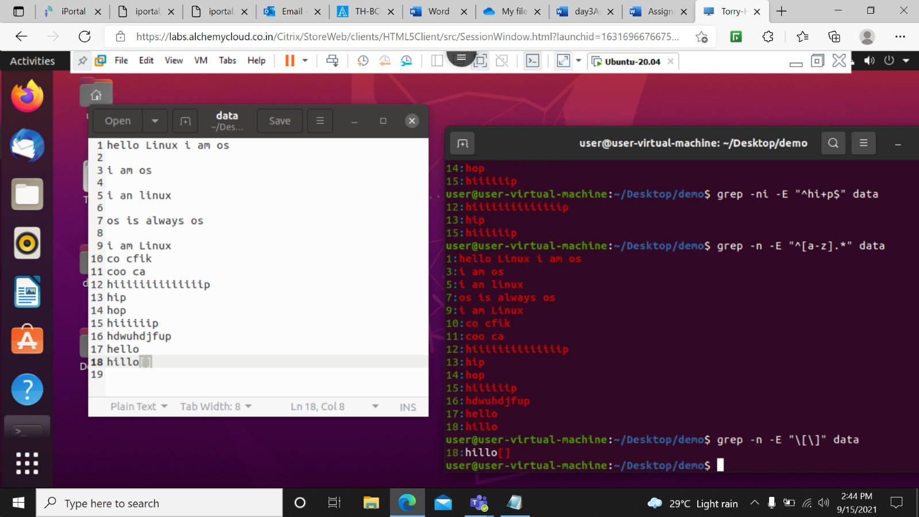

grep –ni –E “^h[^I].\*o$” data- This command will print sting starting with h and ending with p except I in-between starting and ending

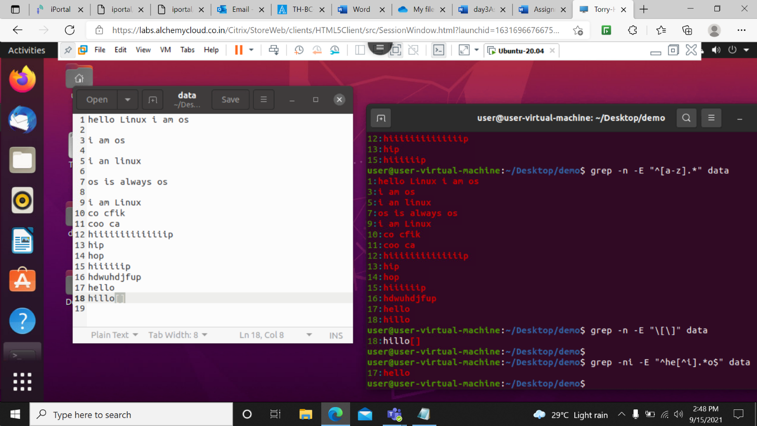

cut –c 4 data- This command is used to print the 4 th column of the file.

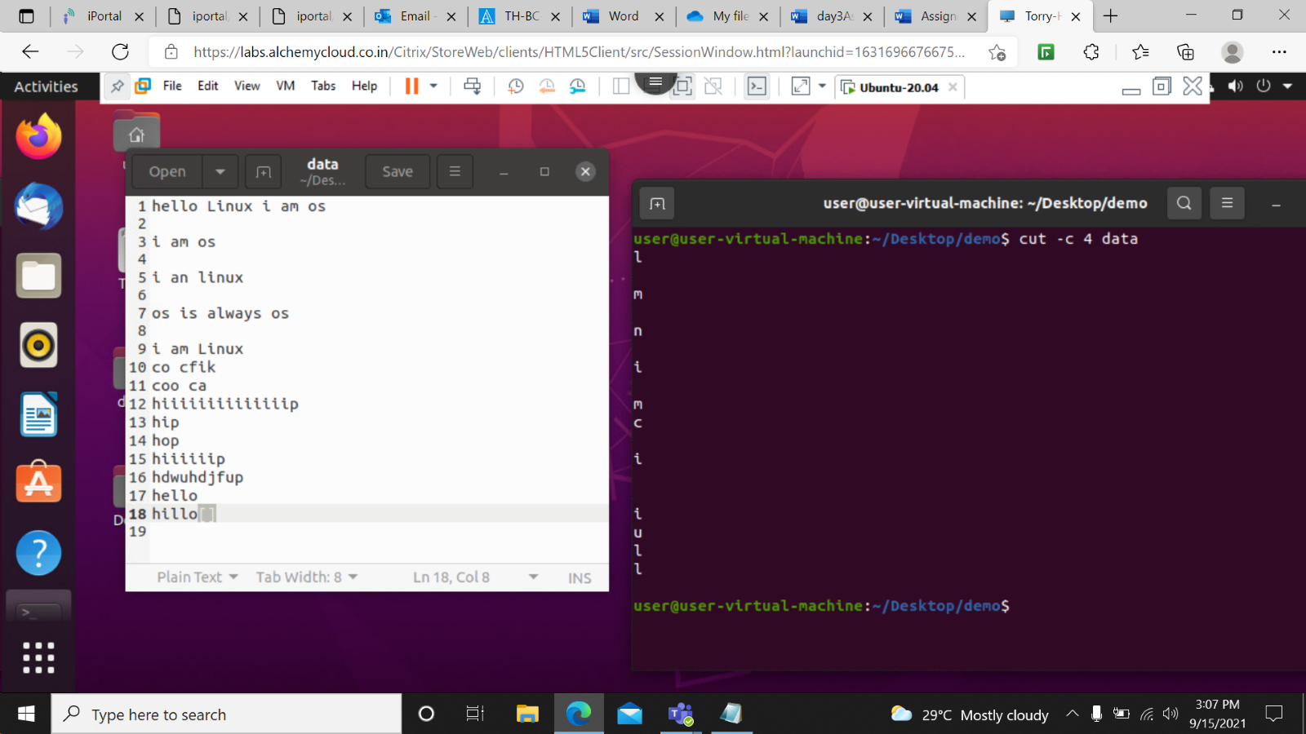

cut –c 1-4 data- This command prints all the columnnn from 1 to 4 fromm the file.

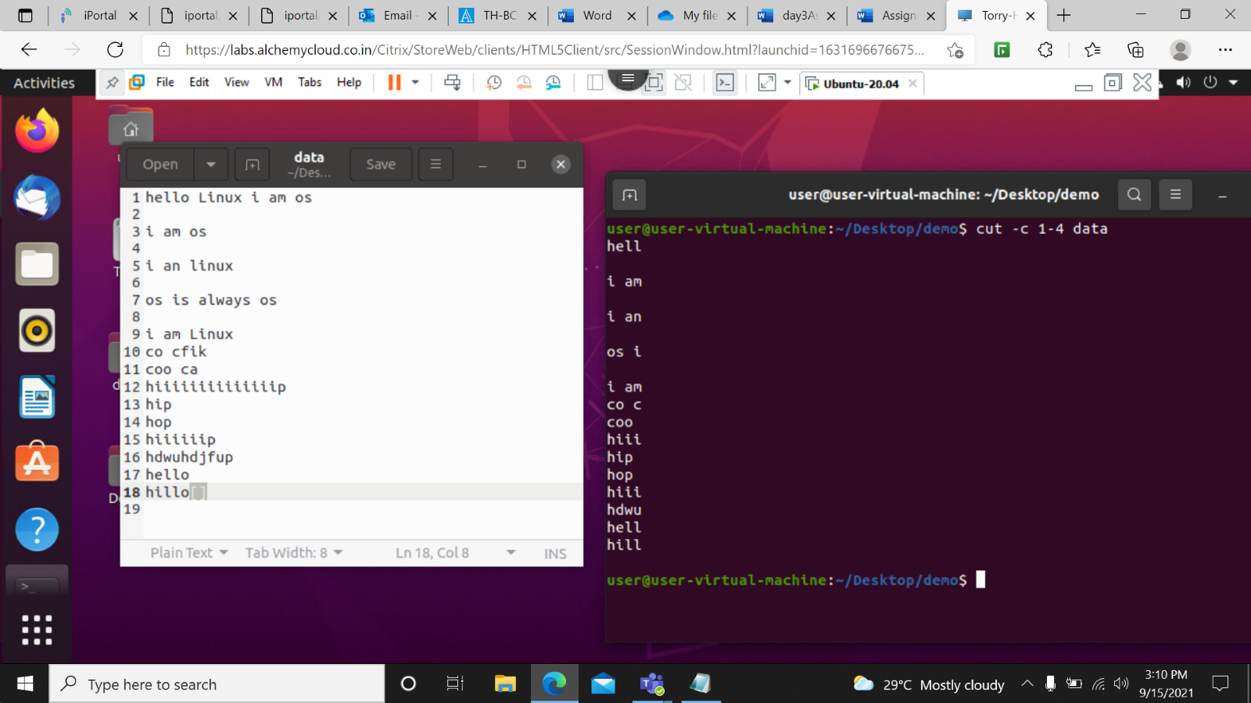

cut –c 1,4 data – this command will print 1st and 4 th column.

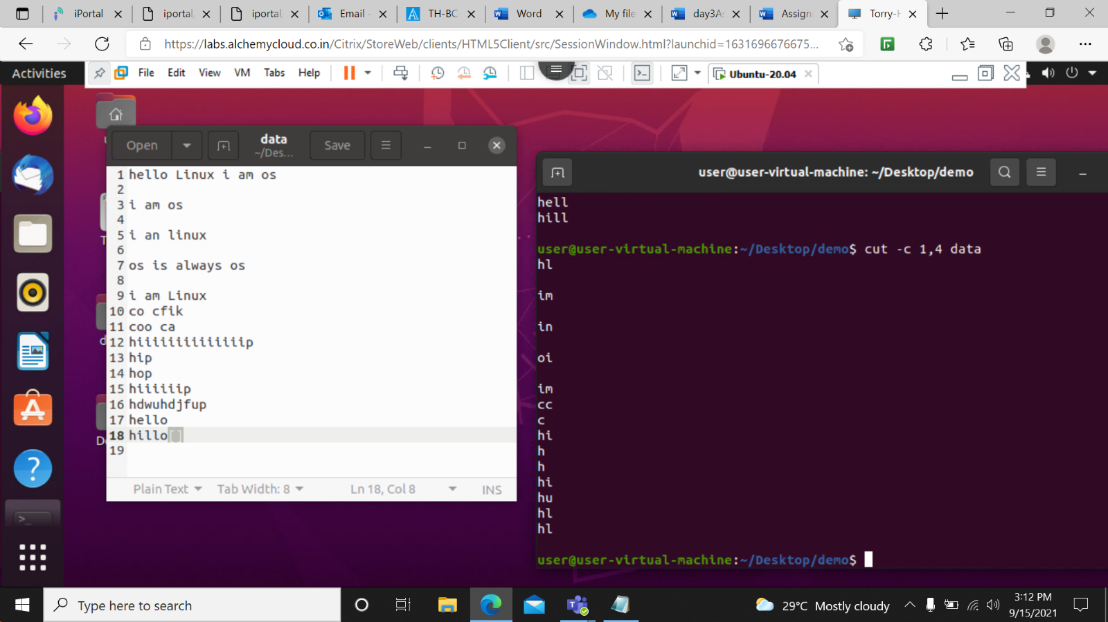

cut –c 1- data- This command is used to print column from 1st to last.

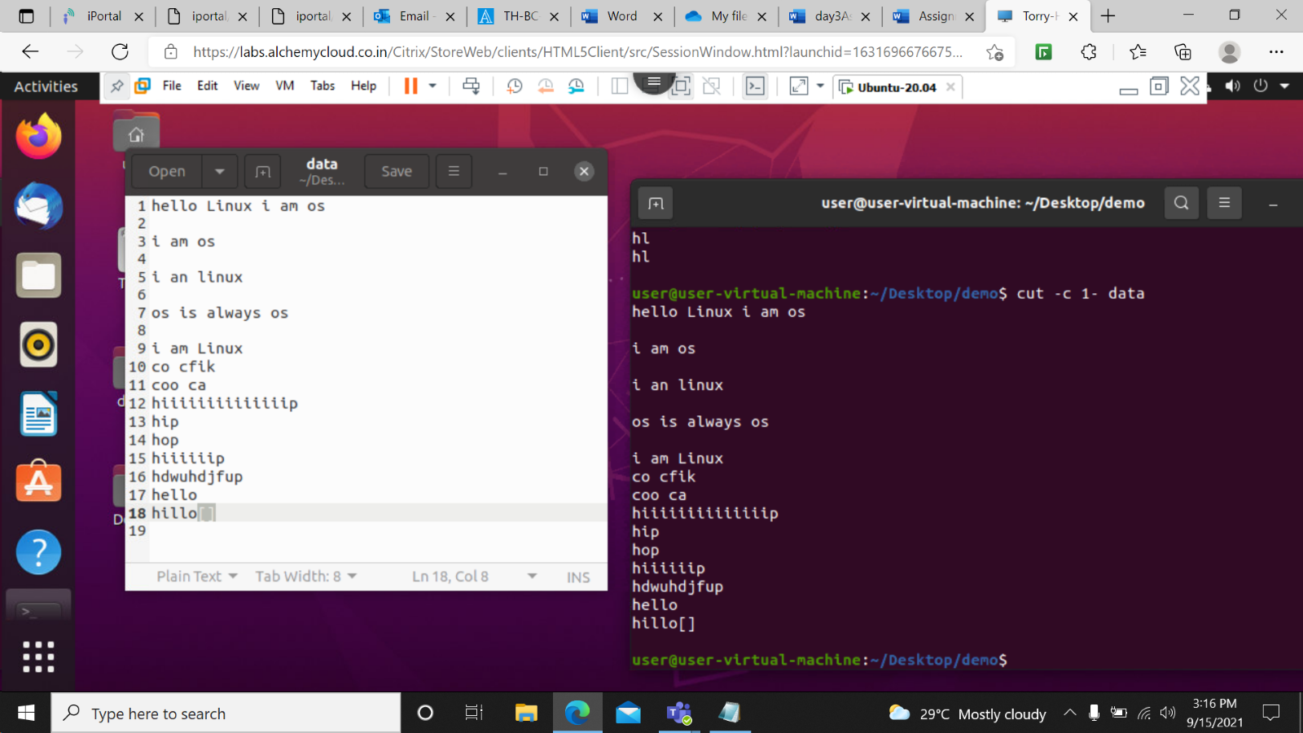

cut –c 4- data- This command eill print columns from 4 till the end.